Hadoop - Big Data Overview

90% of the world’s data was generated in the last few years.

What is Big Data?

Big data means really a big data, it is a collection of large datasets that cannot be processed using traditional computing techniques. Big data is not merely a data, rather it has become a complete subject, which involves various tools, technqiues and frameworks.

What Comes Under Big Data?

Big data involves the data produced by different devices and applications. Given below are some of the fields that come under the umbrella of Big Data.

* **Black Box Data** : It is a component of helicopter, airplanes, and jets, etc. It captures voices of the flight crew, recordings of microphones and earphones, and the performance information of the aircraft.
* **Social Media Data** : Social media such as Facebook and Twitter hold information and the views posted by millions of people across the globe.
* **Stock Exchange Data** : The stock exchange data holds information about the ‘buy’ and ‘sell’ decisions made on a share of different companies made by the customers.
* **Power Grid Data** : The power grid data holds information consumed by a particular node with respect to a base station.
* **Transport Data** : Transport data includes model, capacity, distance and availability of a vehicle.
* **Search Engine Data** : Search engines retrieve lots of data from different databases.



Thus Big Data includes huge volume, high velocity, and extensible variety of data. The data in it will be of three types.

* **Structured data** : Relational data.
* **Semi Structured data** : XML data.
* **Unstructured data** : Word, PDF, Text, Media Logs.

Benefits of Big Data

Big data is really critical to our life and its emerging as one of the most important technologies in modern world. Follow are just few benefits which are very much known to all of us:

* Using the information kept in the social network like Facebook, the marketing agencies are learning about the response for their campaigns, promotions, and other advertising mediums.
* Using the information in the social media like preferences and product perception of their consumers, product companies and retail organizations are planning their production.
* Using the data regarding the previous medical history of patients, hospitals are providing better and quick service.

Big Data Technologies

Big data technologies are important in providing more accurate analysis, which may lead to more concrete decision-making resulting in greater operational efficiencies, cost reductions, and reduced risks for the business.

To harness the power of big data, you would require an infrastructure that can manage and process huge volumes of structured and unstructured data in realtime and can protect data privacy and security.

There are various technologies in the market from different vendors including Amazon, IBM, Microsoft, etc., to handle big data. While looking into the technologies that handle big data, we examine the following two classes of technology:

Operational Big Data

This include systems like MongoDB that provide operational capabilities for real-time, interactive workloads where data is primarily captured and stored.

NoSQL Big Data systems are designed to take advantage of new cloud computing architectures that have emerged over the past decade to allow massive computations to be run inexpensively and efficiently. This makes operational big data workloads much easier to manage, cheaper, and faster to implement.

Some NoSQL systems can provide insights into patterns and trends based on real-time data with minimal coding and without the need for data scientists and additional infrastructure.

Analytical Big Data

This includes systems like Massively Parallel Processing (MPP) database systems and MapReduce that provide analytical capabilities for retrospective and complex analysis that may touch most or all of the data.

MapReduce provides a new method of analyzing data that is complementary to the capabilities provided by SQL, and a system based on MapReduce that can be scaled up from single servers to thousands of high and low end machines.

These two classes of technology are complementary and frequently deployed together.

Operational vs. Analytical Systems

|  |  |  |
| --- | --- | --- |
|  | **Operational** | **Analytical** |
| Latency | 1 ms - 100 ms | 1 min - 100 min |
| Concurrency | 1000 - 100,000 | 1 - 10 |
| Access Pattern | Writes and Reads | Reads |
| Queries | Selective | Unselective |
| Data Scope | Operational | Retrospective |
| End User | Customer | Data Scientist |
| Technology | NoSQL | MapReduce, MPP Database |

Big Data Challenges

The major challenges associated with big data are as follows:

* Capturing data
* Curation
* Storage
* Searching
* Sharing
* Transfer
* Analysis
* Presentation

To fulfill the above challenges, organizations normally take the help of enterprise servers.

Hadoop - Big Data Solutions

Traditional Approach

In this approach, an enterprise will have a computer to store and process big data. Here data will be stored in an RDBMS like Oracle Database, MS SQL Server or DB2 and sophisticated softwares can be written to interact with the database, process the required data and present it to the users for analysis purpose.

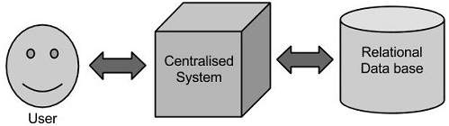

Limitation

This approach works well where we have less volume of data that can be accommodated by standard database servers, or up to the limit of the processor which is processing the data. But when it comes to dealing with huge amounts of data, it is really a tedious task to process such data through a traditional database server.

Google’s Solution

Google solved this problem using an algorithm called MapReduce. This algorithm divides the task into small parts and assigns those parts to many computers connected over the network, and collects the results to form the final result dataset.

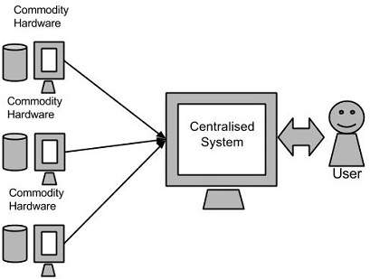

Above diagram shows various commodity hardwares which could be single CPU machines or servers with higher capacity.

Hadoop

Doug Cutting, Mike Cafarella and team took the solution provided by Google and started an Open Source Project called HADOOP in 2005 and Doug named it after his son's toy elephant. Now Apache Hadoop is a registered trademark of the Apache Software Foundation.

Hadoop runs applications using the MapReduce algorithm, where the data is processed in parallel on different CPU nodes. In short, Hadoop framework is capable enough to develop applications capable of running on clusters of computers and they could perform complete statistical analysis for a huge amounts of data.

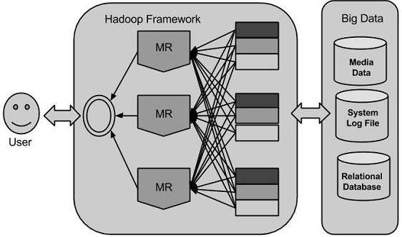

Traditional Approach

In this approach, an enterprise will have a computer to store and process big data. Here data will be stored in an RDBMS like Oracle Database, MS SQL Server or DB2 and sophisticated softwares can be written to interact with the database, process the required data and present it to the users for analysis purpose.



Limitation

This approach works well where we have less volume of data that can be accommodated by standard database servers, or up to the limit of the processor which is processing the data. But when it comes to dealing with huge amounts of data, it is really a tedious task to process such data through a traditional database server.

Google’s Solution

Google solved this problem using an algorithm called MapReduce. This algorithm divides the task into small parts and assigns those parts to many computers connected over the network, and collects the results to form the final result dataset.



Above diagram shows various commodity hardwares which could be single CPU machines or servers with higher capacity.

Hadoop

Doug Cutting, Mike Cafarella and team took the solution provided by Google and started an Open Source Project called HADOOP in 2005 and Doug named it after his son's toy elephant. Now Apache Hadoop is a registered trademark of the Apache Software Foundation.

Hadoop runs applications using the MapReduce algorithm, where the data is processed in parallel on different CPU nodes. In short, Hadoop framework is capable enough to develop applications capable of running on clusters of computers and they could perform complete statistical analysis for a huge amounts of data.



Hadoop Architecture

Hadoop framework includes following four modules:

* **Hadoop Common:** These are Java libraries and utilities required by other Hadoop modules. These libraries provides filesystem and OS level abstractions and contains the necessary Java files and scripts required to start Hadoop.
* **Hadoop YARN:** This is a framework for job scheduling and cluster resource management.
* **Hadoop Distributed File System (HDFS™):** A distributed file system that provides high-throughput access to application data.
* **Hadoop MapReduce:** This is YARN-based system for parallel processing of large data sets.

We can use following diagram to depict these four components available in Hadoop framework.

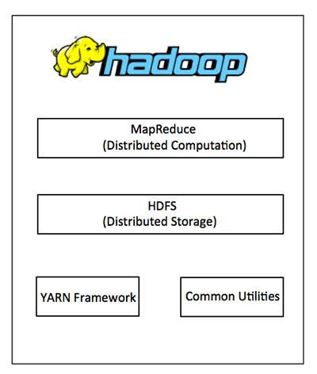

Since 2012, the term "Hadoop" often refers not just to the base modules mentioned above but also to the collection of additional software packages that can be installed on top of or alongside Hadoop, such as Apache Pig, Apache Hive, Apache HBase, Apache Spark etc.

MapReduce

Hadoop **MapReduce** is a software framework for easily writing applications which process big amounts of data in-parallel on large clusters (thousands of nodes) of commodity hardware in a reliable, fault-tolerant manner.

The term MapReduce actually refers to the following two different tasks that Hadoop programs perform:

* **The Map Task:** This is the first task, which takes input data and converts it into a set of data, where individual elements are broken down into tuples (key/value pairs).
* **The Reduce Task:** This task takes the output from a map task as input and combines those data tuples into a smaller set of tuples. The reduce task is always performed after the map task.

Typically both the input and the output are stored in a file-system. The framework takes care of scheduling tasks, monitoring them and re-executes the failed tasks.

The MapReduce framework consists of a single master **JobTracker** and one slave **TaskTracker** per cluster-node. The master is responsible for resource management, tracking resource consumption/availability and scheduling the jobs component tasks on the slaves, monitoring them and re-executing the failed tasks. The slaves TaskTracker execute the tasks as directed by the master and provide task-status information to the master periodically.

The JobTracker is a single point of failure for the Hadoop MapReduce service which means if JobTracker goes down, all running jobs are halted.

Hadoop Distributed File System

Hadoop can work directly with any mountable distributed file system such as Local FS, HFTP FS, S3 FS, and others, but the most common file system used by Hadoop is the Hadoop Distributed File System (HDFS).

The Hadoop Distributed File System (HDFS) is based on the Google File System (GFS) and provides a distributed file system that is designed to run on large clusters (thousands of computers) of small computer machines in a reliable, fault-tolerant manner.

HDFS uses a master/slave architecture where master consists of a single **NameNode** that manages the file system metadata and one or more slave **DataNodes** that store the actual data.

A file in an HDFS namespace is split into several blocks and those blocks are stored in a set of DataNodes. The NameNode determines the mapping of blocks to the DataNodes. The DataNodes takes care of read and write operation with the file system. They also take care of block creation, deletion and replication based on instruction given by NameNode.

HDFS provides a shell like any other file system and a list of commands are available to interact with the file system. These shell commands will be covered in a separate chapter along with appropriate examples.

How Does Hadoop Work?

Stage 1

A user/application can submit a job to the Hadoop (a hadoop job client) for required process by specifying the following items:

1. The location of the input and output files in the distributed file system.
2. The java classes in the form of jar file containing the implementation of map and reduce functions.
3. The job configuration by setting different parameters specific to the job.

Stage 2

The Hadoop job client then submits the job (jar/executable etc) and configuration to the JobTracker which then assumes the responsibility of distributing the software/configuration to the slaves, scheduling tasks and monitoring them, providing status and diagnostic information to the job-client.

Stage 3

The TaskTrackers on different nodes execute the task as per MapReduce implementation and output of the reduce function is stored into the output files on the file system.

Advantages of Hadoop

* Hadoop framework allows the user to quickly write and test distributed systems. It is efficient, and it automatic distributes the data and work across the machines and in turn, utilizes the underlying parallelism of the CPU cores.
* Hadoop does not rely on hardware to provide fault-tolerance and high availability (FTHA), rather Hadoop library itself has been designed to detect and handle failures at the application layer.
* Servers can be added or removed from the cluster dynamically and Hadoop continues to operate without interruption.
* Another big advantage of Hadoop is that apart from being open source, it is compatible on all the platforms since it is Java based.

Hadoop - Enviornment Setup

Pre-installation Setup

Before installing Hadoop into the Linux environment, we need to set up Linux using ssh (Secure Shell). Follow the steps given below for setting up the Linux environment.

Creating a User

At the beginning, it is recommended to create a separate user for Hadoop to isolate Hadoop file system from Unix file system. Follow the steps given below to create a user:

* Open the root using the command “su”.
* Create a user from the root account using the command “useradd username”.
* Now you can open an existing user account using the command “su username”.

Open the Linux terminal and type the following commands to create a user.

$ su

password:

# useradd hadoop

# passwd hadoop

New passwd:

Retype new passwd

SSH Setup and Key Generation

SSH setup is required to do different operations on a cluster such as starting, stopping, distributed daemon shell operations. To authenticate different users of Hadoop, it is required to provide public/private key pair for a Hadoop user and share it with different users.

The following commands are used for generating a key value pair using SSH. Copy the public keys form id_rsa.pub to authorized_keys, and provide the owner with read and write permissions to authorized_keys file respectively.

$ ssh-keygen -t rsa

$ cat ~/.ssh/id_rsa.pub >> ~/.ssh/authorized_keys

$ chmod 0600 ~/.ssh/authorized_keys

Installing Java

Java is the main prerequisite for Hadoop. First of all, you should verify the existence of java in your system using the command “java -version”. The syntax of java version command is given below.

$ java -version

If everything is in order, it will give you the following output.

java version "1.7.0_71"

Java(TM) SE Runtime Environment (build 1.7.0_71-b13)

Java HotSpot(TM) Client VM (build 25.0-b02, mixed mode)

If java is not installed in your system, then follow the steps given below for installing java.

Step 1

Download java (JDK <latest version> - X64.tar.gz) by visiting the following link [http://www.oracle.com/technetwork/java/javase/downloads/jdk7-downloads1880260.html.](http://www.oracle.com/technetwork/java/javase/downloads/jdk7-downloads1880260.html)

Then jdk-7u71-linux-x64.tar.gz will be downloaded into your system.

Step 2

Generally you will find the downloaded java file in Downloads folder. Verify it and extract the jdk-7u71-linux-x64.gz file using the following commands.

$ cd Downloads/

$ ls

jdk-7u71-linux-x64.gz

$ tar zxf jdk-7u71-linux-x64.gz

$ ls

jdk1.7.0_71 jdk-7u71-linux-x64.gz

Step 3

To make java available to all the users, you have to move it to the location “/usr/local/”. Open root, and type the following commands.

$ su

password:

# mv jdk1.7.0_71 /usr/local/

# exit

Step 4

For setting up PATH and JAVA_HOME variables, add the following commands to ~/.bashrc file.

export JAVA_HOME=/usr/local/jdk1.7.0_71

export PATH=$PATH:$JAVA_HOME/bin

Now apply all the changes into the current running system.

$ source ~/.bashrc

Step 5

Use the following commands to configure java alternatives:

# alternatives --install /usr/bin/java java usr/local/java/bin/java 2

# alternatives --install /usr/bin/javac javac usr/local/java/bin/javac 2

# alternatives --install /usr/bin/jar jar usr/local/java/bin/jar 2

# alternatives --set java usr/local/java/bin/java

# alternatives --set javac usr/local/java/bin/javac

# alternatives --set jar usr/local/java/bin/jar

Now verify the java -version command from the terminal as explained above.

Downloading Hadoop

Download and extract Hadoop 2.4.1 from Apache software foundation using the following commands.

$ su

password:

# cd /usr/local

# wget http://apache.claz.org/hadoop/common/hadoop-2.4.1/

hadoop-2.4.1.tar.gz

# tar xzf hadoop-2.4.1.tar.gz

# mv hadoop-2.4.1/* to hadoop/

# exit

Hadoop Operation Modes

Once you have downloaded Hadoop, you can operate your Hadoop cluster in one of the three supported modes:

* **Local/Standalone Mode** : After downloading Hadoop in your system, by default, it is configured in a standalone mode and can be run as a single java process.
* **Pseudo Distributed Mode** : It is a distributed simulation on single machine. Each Hadoop daemon such as hdfs, yarn, MapReduce etc., will run as a separate java process. This mode is useful for development.
* **Fully Distributed Mode** : This mode is fully distributed with minimum two or more machines as a cluster. We will come across this mode in detail in the coming chapters.

Installing Hadoop in Standalone Mode

Here we will discuss the installation of **Hadoop 2.4.1** in standalone mode.

There are no daemons running and everything runs in a single JVM. Standalone mode is suitable for running MapReduce programs during development, since it is easy to test and debug them.

Setting Up Hadoop

You can set Hadoop environment variables by appending the following commands to **~/.bashrc** file.

export HADOOP_HOME=/usr/local/hadoop

Before proceeding further, you need to make sure that Hadoop is working fine. Just issue the following command:

$ hadoop version

If everything is fine with your setup, then you should see the following result:

Hadoop 2.4.1

Subversion https://svn.apache.org/repos/asf/hadoop/common -r 1529768

Compiled by hortonmu on 2013-10-07T06:28Z

Compiled with protoc 2.5.0

From source with checksum 79e53ce7994d1628b240f09af91e1af4

It means your Hadoop's standalone mode setup is working fine. By default, Hadoop is configured to run in a non-distributed mode on a single machine.

Example

Let's check a simple example of Hadoop. Hadoop installation delivers the following example MapReduce jar file, which provides basic functionality of MapReduce and can be used for calculating, like Pi value, word counts in a given list of files, etc.

$HADOOP_HOME/share/hadoop/mapreduce/hadoop-mapreduce-examples-2.2.0.jar

Let's have an input directory where we will push a few files and our requirement is to count the total number of words in those files. To calculate the total number of words, we do not need to write our MapReduce, provided the .jar file contains the implementation for word count. You can try other examples using the same .jar file; just issue the following commands to check supported MapReduce functional programs by hadoop-mapreduce-examples-2.2.0.jar file.

$ hadoop jar $HADOOP_HOME/share/hadoop/mapreduce/hadoop-mapreduceexamples-2.2.0.jar

Step 1

Create temporary content files in the input directory. You can create this input directory anywhere you would like to work.

$ mkdir input

$ cp $HADOOP_HOME/*.txt input

$ ls -l input

It will give the following files in your input directory:

total 24

-rw-r--r-- 1 root root 15164 Feb 21 10:14 LICENSE.txt

-rw-r--r-- 1 root root 101 Feb 21 10:14 NOTICE.txt

-rw-r--r-- 1 root root 1366 Feb 21 10:14 README.txt

These files have been copied from the Hadoop installation home directory. For your experiment, you can have different and large sets of files.

Step 2

Let's start the Hadoop process to count the total number of words in all the files available in the input directory, as follows:

$ hadoop jar $HADOOP_HOME/share/hadoop/mapreduce/hadoop-mapreduceexamples-2.2.0.jar wordcount input output

Step 3

Step-2 will do the required processing and save the output in output/part-r00000 file, which you can check by using:

$cat output/*

It will list down all the words along with their total counts available in all the files available in the input directory.

"AS 4

"Contribution" 1

"Contributor" 1

"Derivative 1

"Legal 1

"License" 1

"License"); 1

"Licensor" 1

"NOTICE” 1

"Not 1

"Object" 1

"Source” 1

"Work” 1

"You" 1

"Your") 1

"[]" 1

"control" 1

"printed 1

"submitted" 1

(50%) 1

(BIS), 1

(C) 1

(Don't) 1

(ECCN) 1

(INCLUDING 2

(INCLUDING, 2

.............

Installing Hadoop in Pseudo Distributed Mode

Follow the steps given below to install Hadoop 2.4.1 in pseudo distributed mode.

Step 1: Setting Up Hadoop

You can set Hadoop environment variables by appending the following commands to **~/.bashrc** file.

export HADOOP_HOME=/usr/local/hadoop

export HADOOP_MAPRED_HOME=$HADOOP_HOME

export HADOOP_COMMON_HOME=$HADOOP_HOME

export HADOOP_HDFS_HOME=$HADOOP_HOME

export YARN_HOME=$HADOOP_HOME

export HADOOP_COMMON_LIB_NATIVE_DIR=$HADOOP_HOME/lib/native

export PATH=$PATH:$HADOOP_HOME/sbin:$HADOOP_HOME/bin

export HADOOP_INSTALL=$HADOOP_HOME

Now apply all the changes into the current running system.

$ source ~/.bashrc

Step 2: Hadoop Configuration

You can find all the Hadoop configuration files in the location “$HADOOP_HOME/etc/hadoop”. It is required to make changes in those configuration files according to your Hadoop infrastructure.

$ cd $HADOOP_HOME/etc/hadoop

In order to develop Hadoop programs in java, you have to reset the java environment variables in **hadoop-env.sh** file by replacing **JAVA_HOME** value with the location of java in your system.

export JAVA_HOME=/usr/local/jdk1.7.0_71

The following are the list of files that you have to edit to configure Hadoop.

**core-site.xml**

The **core-site.xml** file contains information such as the port number used for Hadoop instance, memory allocated for the file system, memory limit for storing the data, and size of Read/Write buffers.

Open the core-site.xml and add the following properties in between <configuration>, </configuration> tags.

<configuration>

<property>

<name>fs.default.name </name>

<value> hdfs://localhost:9000 </value>

</property>

</configuration>

**hdfs-site.xml**

The **hdfs-site.xml** file contains information such as the value of replication data, namenode path, and datanode paths of your local file systems. It means the place where you want to store the Hadoop infrastructure.

Let us assume the following data.

dfs.replication (data replication value) = 1

(In the below given path /hadoop/ is the user name.

hadoopinfra/hdfs/namenode is the directory created by hdfs file system.)

namenode path = //home/hadoop/hadoopinfra/hdfs/namenode

(hadoopinfra/hdfs/datanode is the directory created by hdfs file system.)

datanode path = //home/hadoop/hadoopinfra/hdfs/datanode

Open this file and add the following properties in between the <configuration> </configuration> tags in this file.

<configuration>

<property>

<name>dfs.replication</name>

<value>1</value>

</property>

<property>

<name>dfs.name.dir</name>

<value>file:///home/hadoop/hadoopinfra/hdfs/namenode </value>

</property>

<property>

<name>dfs.data.dir</name>

<value>file:///home/hadoop/hadoopinfra/hdfs/datanode </value>

</property>

</configuration>

**Note:** In the above file, all the property values are user-defined and you can make changes according to your Hadoop infrastructure.

**yarn-site.xml**

This file is used to configure yarn into Hadoop. Open the yarn-site.xml file and add the following properties in between the <configuration>, </configuration> tags in this file.

<configuration>

<property>

<name>yarn.nodemanager.aux-services</name>

<value>mapreduce_shuffle</value>

</property>

</configuration>

**mapred-site.xml**

This file is used to specify which MapReduce framework we are using. By default, Hadoop contains a template of yarn-site.xml. First of all, it is required to copy the file from **mapred-site,xml.template** to **mapred-site.xml** file using the following command.

$ cp mapred-site.xml.template mapred-site.xml

Open mapred-site.xml file and add the following properties in between the <configuration>, </configuration>tags in this file.

<configuration>

<property>

<name>mapreduce.framework.name</name>

<value>yarn</value>

</property>

</configuration>

Verifying Hadoop Installation

The following steps are used to verify the Hadoop installation.

Step 1: Name Node Setup

Set up the namenode using the command “hdfs namenode -format” as follows.

$ cd ~

$ hdfs namenode -format

The expected result is as follows.

10/24/14 21:30:55 INFO namenode.NameNode: STARTUP_MSG:

/************************************************************

STARTUP_MSG: Starting NameNode

STARTUP_MSG: host = localhost/192.168.1.11

STARTUP_MSG: args = [-format]

STARTUP_MSG: version = 2.4.1

...

...

10/24/14 21:30:56 INFO common.Storage: Storage directory

/home/hadoop/hadoopinfra/hdfs/namenode has been successfully formatted.

10/24/14 21:30:56 INFO namenode.NNStorageRetentionManager: Going to

retain 1 images with txid >= 0

10/24/14 21:30:56 INFO util.ExitUtil: Exiting with status 0

10/24/14 21:30:56 INFO namenode.NameNode: SHUTDOWN_MSG:

/************************************************************

SHUTDOWN_MSG: Shutting down NameNode at localhost/192.168.1.11

************************************************************/

Step 2: Verifying Hadoop dfs

The following command is used to start dfs. Executing this command will start your Hadoop file system.

$ start-dfs.sh

The expected output is as follows:

10/24/14 21:37:56

Starting namenodes on [localhost]

localhost: starting namenode, logging to /home/hadoop/hadoop

2.4.1/logs/hadoop-hadoop-namenode-localhost.out

localhost: starting datanode, logging to /home/hadoop/hadoop

2.4.1/logs/hadoop-hadoop-datanode-localhost.out

Starting secondary namenodes [0.0.0.0]

Step 3: Verifying Yarn Script

The following command is used to start the yarn script. Executing this command will start your yarn daemons.

$ start-yarn.sh

The expected output as follows:

starting yarn daemons

starting resourcemanager, logging to /home/hadoop/hadoop

2.4.1/logs/yarn-hadoop-resourcemanager-localhost.out

localhost: starting nodemanager, logging to /home/hadoop/hadoop

2.4.1/logs/yarn-hadoop-nodemanager-localhost.out

Step 4: Accessing Hadoop on Browser

The default port number to access Hadoop is 50070. Use the following url to get Hadoop services on browser.

http://localhost:50070/

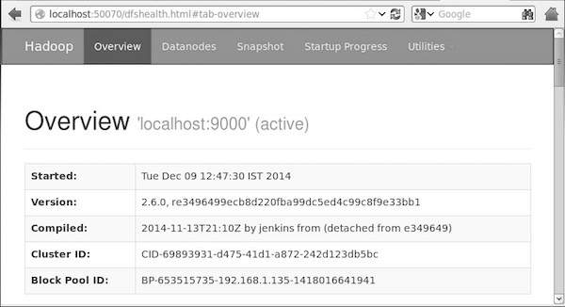

Step 5: Verify All Applications for Cluster

The default port number to access all applications of cluster is 8088. Use the following url to visit this service.

http://localhost:8088/

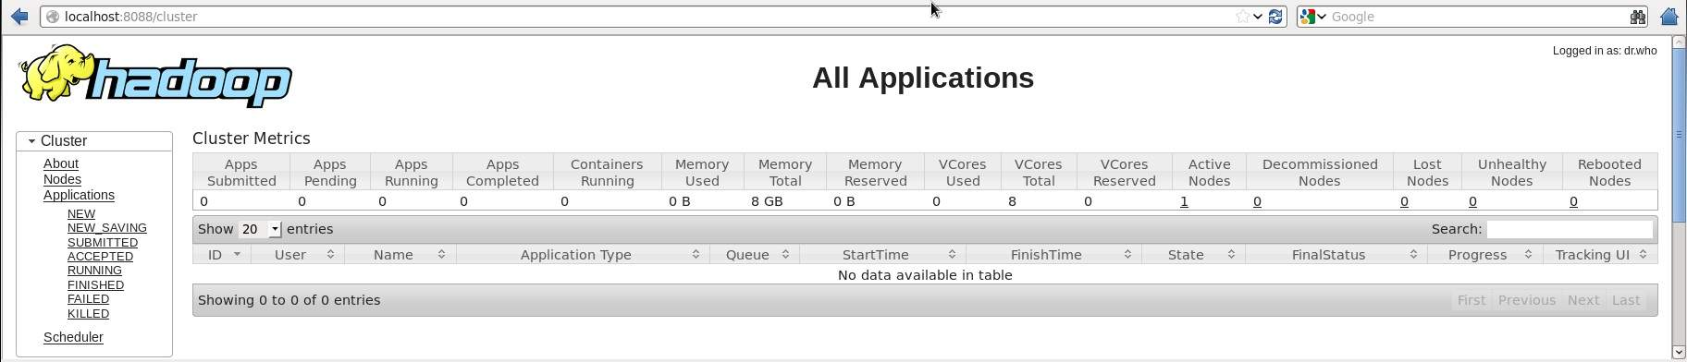

Hadoop - HDFS Overview

HDFS holds very large amount of data and provides easier access. To store such huge data, the files are stored across multiple machines. These files are stored in redundant fashion to rescue the system from possible data losses in case of failure. HDFS also makes applications available to parallel processing.

Features of HDFS

* It is suitable for the distributed storage and processing.
* Hadoop provides a command interface to interact with HDFS.
* The built-in servers of namenode and datanode help users to easily check the status of cluster.
* Streaming access to file system data.
* HDFS provides file permissions and authentication.

HDFS Architecture

Given below is the architecture of a Hadoop File System.

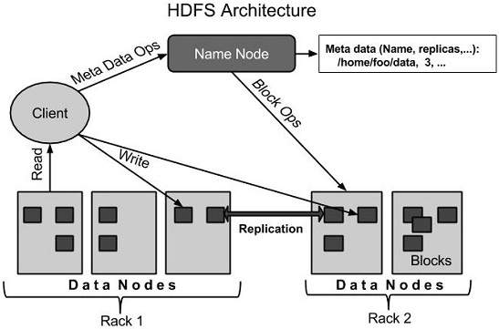

HDFS follows the master-slave architecture and it has the following elements.

Namenode

The namenode is the commodity hardware that contains the GNU/Linux operating system and the namenode software. It is a software that can be run on commodity hardware. The system having the namenode acts as the master server and it does the following tasks:

* Manages the file system namespace.
* Regulates client’s access to files.
* It also executes file system operations such as renaming, closing, and opening files and directories.

Datanode

The datanode is a commodity hardware having the GNU/Linux operating system and datanode software. For every node (Commodity hardware/System) in a cluster, there will be a datanode. These nodes manage the data storage of their system.

* Datanodes perform read-write operations on the file systems, as per client request.
* They also perform operations such as block creation, deletion, and replication according to the instructions of the namenode.

Block

Generally the user data is stored in the files of HDFS. The file in a file system will be divided into one or more segments and/or stored in individual data nodes. These file segments are called as blocks. In other words, the minimum amount of data that HDFS can read or write is called a Block. The default block size is 64MB, but it can be increased as per the need to change in HDFS configuration.

Goals of HDFS

* **Fault detection and recovery** : Since HDFS includes a large number of commodity hardware, failure of components is frequent. Therefore HDFS should have mechanisms for quick and automatic fault detection and recovery.
* **Huge datasets** : HDFS should have hundreds of nodes per cluster to manage the applications having huge datasets.
* **Hardware at data** : A requested task can be done efficiently, when the computation takes place near the data. Especially where huge datasets are involved, it reduces the network traffic and increases the throughput.

Hadoop - HDFS Operations

Starting HDFS

Initially you have to format the configured HDFS file system, open namenode (HDFS server), and execute the following command.

$ hadoop namenode -format

After formatting the HDFS, start the distributed file system. The following command will start the namenode as well as the data nodes as cluster.

$ start-dfs.sh

Listing Files in HDFS

After loading the information in the server, we can find the list of files in a directory, status of a file, using ‘ls’. Given below is the syntax of ls that you can pass to a directory or a filename as an argument.

$ $HADOOP_HOME/bin/hadoop fs -ls <args>

Inserting Data into HDFS

Assume we have data in the file called file.txt in the local system which is ought to be saved in the hdfs file system. Follow the steps given below to insert the required file in the Hadoop file system.

Step 1

You have to create an input directory.

$ $HADOOP_HOME/bin/hadoop fs -mkdir /user/input

Step 2

Transfer and store a data file from local systems to the Hadoop file system using the put command.

$ $HADOOP_HOME/bin/hadoop fs -put /home/file.txt /user/input

Step 3

You can verify the file using ls command.

$ $HADOOP_HOME/bin/hadoop fs -ls /user/input

Retrieving Data from HDFS

Assume we have a file in HDFS called outfile. Given below is a simple demonstration for retrieving the required file from the Hadoop file system.

Step 1

Initially, view the data from HDFS using cat command.

$ $HADOOP_HOME/bin/hadoop fs -cat /user/output/outfile

Step 2

Get the file from HDFS to the local file system using get command.

$ $HADOOP_HOME/bin/hadoop fs -get /user/output/ /home/hadoop_tp/

Shutting Down the HDFS

You can shut down the HDFS by using the following command.

$ stop-dfs.sh

Hadoop - Command Reference

There are many more commands in **"$HADOOP_HOME/bin/hadoop fs"** than are demonstrated here, although these basic operations will get you started. Running ./bin/hadoop dfs with no additional arguments will list all the commands that can be run with the FsShell system. Furthermore, **$HADOOP_HOME/bin/hadoop fs -help** commandName will display a short usage summary for the operation in question, if you are stuck.

A table of all the operations is shown below. The following conventions are used for parameters:

"<path>" means any file or directory name.

"<path>..." means one or more file or directory names.

"<file>" means any filename.

"<src>" and "<dest>" are path names in a directed operation.

"<localSrc>" and "<localDest>" are paths as above, but on the local file system.

All other files and path names refer to the objects inside HDFS.

|  |  |
| --- | --- |
| 1. | **ls <path>**  Lists the contents of the directory specified by path, showing the names, permissions, owner, size and modification date for each entry. |
| 2. | **lsr <path>**  Behaves like -ls, but recursively displays entries in all subdirectories of path. |
| 3. | **du <path>**  Shows disk usage, in bytes, for all the files which match path; filenames are reported with the full HDFS protocol prefix. |
| 4. | **dus <path>**  Like -du, but prints a summary of disk usage of all files/directories in the path. |
| 5. | **mv <src><dest>**  Moves the file or directory indicated by src to dest, within HDFS. |
| 6. | **cp <src> <dest>**  Copies the file or directory identified by src to dest, within HDFS. |
| 7. | **rm <path>**  Removes the file or empty directory identified by path. |
| 8. | **rmr <path>**  Removes the file or directory identified by path. Recursively deletes any child entries (i.e., files or subdirectories of path). |
| 9. | **put <localSrc> <dest>**  Copies the file or directory from the local file system identified by localSrc to dest within the DFS. |
| 10. | **copyFromLocal <localSrc> <dest>**  Identical to -put |
| 11. | **moveFromLocal <localSrc> <dest>**  Copies the file or directory from the local file system identified by localSrc to dest within HDFS, and then deletes the local copy on success. |
| 12. | **get [-crc] <src> <localDest>**  Copies the file or directory in HDFS identified by src to the local file system path identified by localDest. |
| 13. | **getmerge <src> <localDest>**  Retrieves all files that match the path src in HDFS, and copies them to a single, merged file in the local file system identified by localDest. |
| 14. | **cat <filen-ame>**  Displays the contents of filename on stdout. |
| 15. | **copyToLocal <src> <localDest>**  Identical to -get |
| 16. | **moveToLocal <src> <localDest>**  Works like -get, but deletes the HDFS copy on success. |
| 17. | **mkdir <path>**  Creates a directory named path in HDFS.  Creates any parent directories in path that are missing (e.g., mkdir -p in Linux). |
| 18. | **setrep [-R] [-w] rep <path>**  Sets the target replication factor for files identified by path to rep. (The actual replication factor will move toward the target over time) |
| 19. | **touchz <path>**  Creates a file at path containing the current time as a timestamp. Fails if a file already exists at path, unless the file is already size 0. |
| 20. | **test -[ezd] <path>**  Returns 1 if path exists; has zero length; or is a directory or 0 otherwise. |
| 21. | **stat [format] <path>**  Prints information about path. Format is a string which accepts file size in blocks (%b), filename (%n), block size (%o), replication (%r), and modification date (%y, %Y). |
| 22. | **tail [-f] <file2name>**  Shows the last 1KB of file on stdout. |
| 23. | **chmod [-R] mode,mode,... <path>...**  Changes the file permissions associated with one or more objects identified by path.... Performs changes recursively with R. mode is a 3-digit octal mode, or {augo}+/-{rwxX}. Assumes if no scope is specified and does not apply an umask. |
| 24. | **chown [-R] [owner][:[group]] <path>...**  Sets the owning user and/or group for files or directories identified by path.... Sets owner recursively if -R is specified. |
| 25. | chgrp [-R] group <path>...  Sets the owning group for files or directories identified by path.... Sets group recursively if -R is specified. |
| 26. | **help <cmd-name>**  Returns usage information for one of the commands listed above. You must omit the leading '-' character in cmd. |